GeoiDempiere

TRIGGER sulla Tabella inserimento di lit_geographicobject

set search_path to adempiere,public;

update lit_geographicobject set point_geom=st_point(lon,lat);

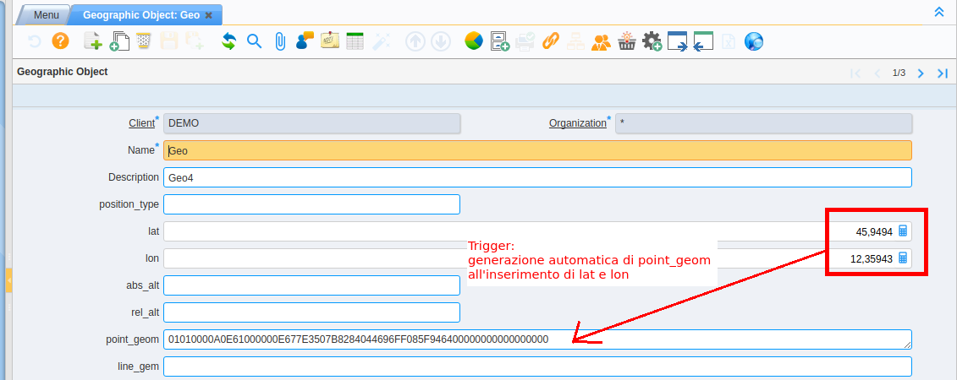

--

select * from pg_stat_activity where datname='idempiere'

--

set search_path to adempiere,public;

update lit_geographicobject set point_geom=st_setsrid(st_makepoint(lon,lat,0), 4326);

---

TO DO

abs_lat -> numeric

rel_alt > numeric

---

SELECT

pg_terminate_backend(pid)

FROM

pg_stat_activity

WHERE

-- don't kill my own connection!

pid <> pg_backend_pid()

-- don't kill the connections to other databases

AND datname = 'database_name'

;

installare php5

installare apget- install php5-pgsql

errore pdo fetch

Riunione 4 ottobre 2017

Apertura maschera per richiedere posizionamento